This is our new offering where we take advantage of our close proximity to major electronics manufacturers and pass on the savings to you.
As you may or may not know, Seeed Studio is located in Shenzhen, China where the vast majority of the world’s computer components and electronics are fabricated. An offshoot of this is the Hua QiangBei district, the largest electronics market in the world located in downtown Shenzhen. The market consists of thousands of stalls selling everything from memory to cell phones. It has great prices with a no-frills approach.
Knowing that our Makers would love the opportunity to shop in this electronics paradise, we decided to bring it you. We’ve sourced fabulous items at rock bottom prices; plus, we’ve added some extra perks that you won’t find at the market. We will be providing basic documentation in English, and we will maintain our return policy for these market-direct items.
We’ve started out with LEDs and EL wire because they are fun and great for all sorts of projects. Our next step is to add more unique items that are a bit harder to come by. You’ll want to check back ever week, to see what’s new to the catalogue.
So don’t be shy. Take advantage of these great deals and enjoy.

Sensor
Button
Tools
Case
LED&Laser
Wire
Display
RF(RFID)
Motor
Board
Camera
Voltmeter& Converter
Adapter
Battery
Development Kit
Others
Robot

Sensor | Name | SKU | Price
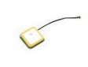 | Embedded Antenna U.FL for GPS | WLS121C2B | $5.50
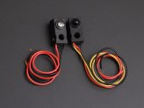 | 300mm Infrared shooting sensor | 101990073 | $6.60
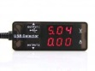 | USB Current Voltage Detector | 114990067 | $12.90
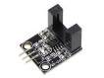 | Motor Speed Sensor Module | 114990070 | $2.95
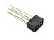 | Photo Reflective Sensor | SEN130A3B | $2.00
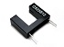 | Photointerrupter (OS25B10) | SEN129A3B | $1.5
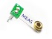 | Piezo Sensor - MiniSense 100 | SEN127A3M | $2.85
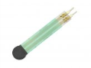 | 0.2 Inch Thin Film Resistor type Pressure Sensor - FSR400 A301 | 114990107 | $19.95
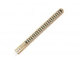 | 2.2 Inch Bend Sensor - A201 | 114990106 | $25.95
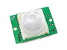 | PIR Motion sensor module | SEN116A2B | $5.9
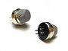 | Smoke Sensor | SEN117A2B | $4.95
 | Gas Sensor -MQ5 | SEN105A2B | $3.95
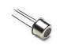 | Alcohol Sensor MQ303A | SEN132A3B | $5.5
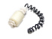 | water level switch | SEN134B3B | $5.50
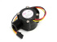 | G1/2" Water Flow Sensor | POW110D3B | $9.50
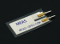 | Piezo Vibration Sensor | SEN92753M | $2.85
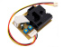 | Grove - Dust Sensor | SEN12291P | $15.90
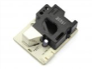 | Smart Dust Sensor - SM-PWM-01A | 114990092 | $16.95
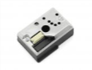 | Compact Optical Dust Sensor - GP2Y1010AU0F | 114990091 | $9.95
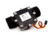 | G5/4" Water Flow Sensor | SEN02142B | $29.50
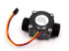 | G3/4" Water Flow Sensor | SEN02141B | $14.90
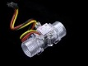 | G1/2" Water Flow Sensor Enclosure | 101990055 | $9.50
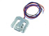 | Load Sensor | TEM01052B | $4.90
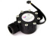 | G1" Water Flow Sensor | 209015001 | $15.90
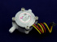 | G1/4" Water Flow Sensor | TEM01071B | $9.50
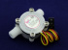 | G1/8" Water Flow Sensor | TEM01072B | $9.50
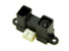 | Analog Infrared Distance Measuring Sensor(20-150cm) | SEN05312B | $16.90
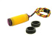 | Adjustable IR Reflection Sensor(3- 80cm) | SEN05311B | $6.90
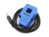 | Non-invasive AC Current Sensor (30A max) | THM104C4B | $9.5
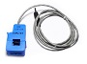 | Non-invasive AC Current Sensor (100A max) | THM105C4B | $11.5
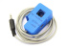 | Non-invasive AC Current Sensor (5A max) | 101990058 | $6.90
 | Non-invasive AC Current Sensor (10A max) | 101990059 | $6.90
 | Non-invasive AC Current Sensor (15A max) | 101990060 | $6.90
 | Non-invasive AC Current Sensor (20A max) | 101990061 | $6.90
 | Non-invasive AC Current Sensor (25A max) | 101990062 | $6.90
 | Non-invasive AC Current Sensor (50A max) | 101990063 | $6.90
 | Non-invasive AC Current Sensor (60A max) | 101990064 | $6.90
 | Non-invasive AC Current Sensor (70A max) | 101990065 | $6.90
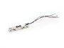 | Weight Sensor (Load Cell) 0-500g | SEN128A3B | $17
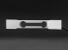 | Weight Sensor (Load Cell) 0-3kg | 114990093 | $9.95
 | Weight Sensor (Load Cell) 0-5kg | 114990094 | $9.95
 | Weight Sensor (Load Cell) 0-50kg | 114990100 | $9.95
 | Weight Sensor (Load Cell) 0-40kg | 114990099 | $9.95
 | Weight Sensor (Load Cell) 0-30kg | 114990098 | $9.95
 | Weight Sensor (Load Cell) 0-20kg | 114990097 | $9.95
 | Weight Sensor (Load Cell) 0-10kg | 114990096 | $9.95
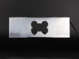 | Weight Sensor (Load Cell) 0-800kg | 114990105 | $32.00
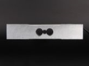 | Weight Sensor (Load Cell) 0-400kg | 114990104 | $16.00
 | Weight Sensor (Load Cell) 0-350kg | 114990103 | $14.90
 | Weight Sensor (Load Cell) 0-200kg | 114990102 | $13.00
 | Weight Sensor (Load Cell) 0-150kg | 114990101 | $13.50
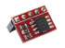 | Temperature sensor for Raspberry Pi - LM75 | 101990066 | $7.90
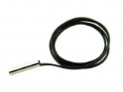 | Temperature sensor with steel head | SEN118A2B | $1.50
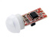 | Mini PIR Motion Sensor Module | 800130001 | $5.90
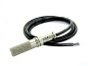 | Soil Moisture & Temperature Sensor | TEM01162B | $39.90
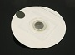 | Disposable ECG Electrode (10 Pcs pack) | MED60389M | $1.99
Button | Name | SKU | Price
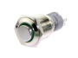 | 16mm Momentary Metal Illuminated Push Button - Green LED | 800165001 | $6.50
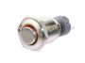 | 16mm Momentary Metal Illuminated Push Button - Orange LED | 800167001 | $6.50
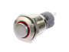 | 16mm Momentary Metal Illuminated Push Button - Red LED | 800164001 | $6.50
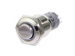 | 16mm Momentary Metal Illuminated Push Button - White LED | 800169001 | $6.50
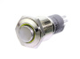 | 16mm Momentary Metal Illuminated Push Button - Yellow LED | 800166001 | $6.50
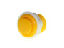 | 27.5mm Arcade Game Push Button - Yellow | TEM12284B | $0.90
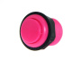 | 27.5mm Arcade Game Push Button - Pink | TEM12283B | $0.90
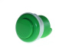 | 33mm Arcade Game Push Button - Green | TEM12282B | $0.90
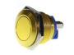 | 16mm Anti-vandal Metal Push Button - Glory Gold | TEM12122B | $3.50
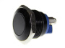 | 16mm Anti-vandal Metal Push Button - Carbon Black | TEM12123B | $3.50
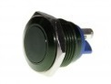 | 16mm Anti-vandal Metal Push Button - Dark Green | TEM12124B | $3.50
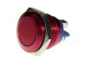 | 16mm Anti-vandal Metal Push Button - Crimson Red | TEM12125B | $3.50
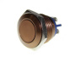 | 16mm Anti-vandal Metal Push Button - Chocolate Brow | TEM12126B | $3.50
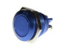 | 16mm Anti-vandal Metal Push Button - Royal Blue | TEM12127B | $3.50
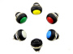 | 12mm Domed Push Button Pack | TEM12121B | $3.00
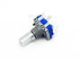 | Rotary Encoder with Switch | SWT112A2B | $3.70
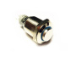 | Metal Push button - Momentary w/ Blue LED | SWT101A2B | $6.50
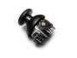 | Analog joystick | SWT111C5B | $3.90
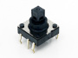 | ALPS SKQU 4 direction Joystick w/ Switch | SWT105A2B | $2.00
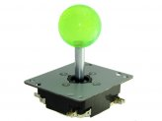 | Arcade Joystick | TEM01051B | $11.90
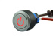 | Latching Pushbutton Switch With Power Logo | TEM04011B | $4.50
 | The never_going_to_miss glaring_devil_eye Huge Red Push Button | SWT120B7B | $9.90
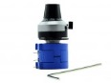 | Dial-type Potentiometer(10k) | TEM12271B | $6.90
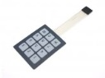 | Sealed Membrane 3x4 button pad with sticker | COM62229M | $3.49
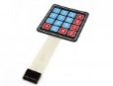 | Sealed Membrane 4*4 button pad with sticker | SWT114A2B | $7.50
Tools | Name | SKU | Price
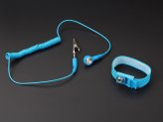 | Antistatic wrist strap | 114990185 | $1.95
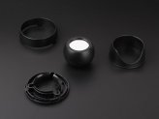 | Laser mirror | 114990186 | $9.50
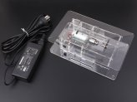 | MINI saw bench | 114990187 | $45.00
 | MINI table vise | 114990188 | $3.25
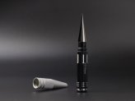 | 0-14mm hole saw | 114990189 | $8.90
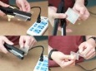 | Acrylic bender | 114990154 | $29.95
 | Foam Cutter-26cm with copper transformer | 110990453 | $25.95
 | Foam Cutter-16cm with electronic transformer | 110990452 | $21.50
 | Foam Cutter-11cm with electronic transformer | 110990451 | $18.00
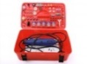 | MINI electric drill kits -161pcs | 110990456 | $31.50
 | Hacksaw kits | 110990454 | $8.95
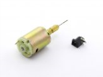 | 12V PCB DC Motor drill | 404990001 | $3.95
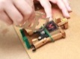 | Universal steel ruler 11 in 1 | 114990156 | $2.50
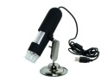 | USB Digital Microscope | TEM03281B | $45.50
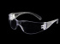 | Soldering Safety Glasses - Transparent | 620039001 | $3.90
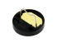 | Mini Soldering Iron Stand | 620036001 | $0.90
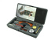 | Cordless Battery - Battery powered Soldering Iron Kit | TOL05251B | $29.90
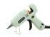 | Mini Hot Glue Gun | TOL05212B | $3.90
 | Hot Glue Sticks - 5pcs | TOL05211B | $1.00
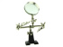 | Third-hand Tool With Magnifying Glass | ACC04281B | $5.90
 | Desoldering Wick | ACC04261B | $2.50
 | Desoldering Pump | ACC04252B | $2.90
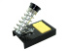 | Soldering Iron Stand | ACC04251B | $3.90
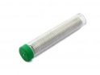 | Lead Free Solder Wire | TEM01041B | $1.50
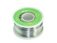 | Lead-free Solder Spool(100g) | TOL04242B | $6.50
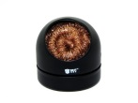 | Iron Cleaner | TEM01111B | $4.90
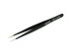 | Straight Tweezers - ESD Safe | TOL04241B | $2.50
 | Diagonal Pliers | ACC04232B | $4.90
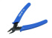 | Flush Diagonal Cutters | ACC04231B | $2.90
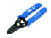 | Wire Strippers | ACC04221B | $4.90
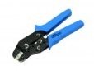 | Ratcheting Crimper Pliers | TOL00600B | $16.90
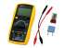 | Digital Capacitance Meter | TES04081B | $34.90
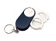 | Magnifying glass with LED | TEM03231B | $4.50
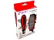 | 38-In-1 Interchangeable precise manual tool set JK-6088 | ACC12291B | $8.99
Case | Name | SKU | Price
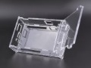 | Cubieboard A20 Acrylic Enclosure | 114990136 | $4.50
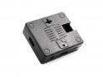 | Raspberry Pi A+ Enclosure - Black | 114990194 | $4.95
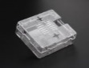 | Raspberry Pi A+ Enclosure - Transparent | 14990195 | $4.95
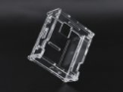 | Raspberry Pi A+ Acrylic Enclosure - Clear | 114990196 | $2.95
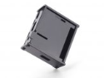 | Raspberry Pi A+ Acrylic Enclosure - Black | 114990199 | $2.95
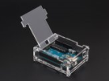 | Arduino UNO R3 Acrylic Enclosure - Clear | 114990198 | $5.95
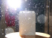 | ABS outdoor waterproof Case 163×105×40 mm | 114990140 | 1.35
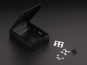 | Raspberry pi B+ iron box | 114990179 | $26.50
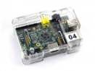 | Raspberry Pi Clear PS Enclosure | 389016001 | $3.90
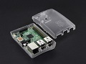 | Raspberry Pi B+ Arc Enclosure - Transparent | 114990126 | $9.95
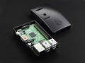 | Raspberry Pi B+ Arc Enclosure - Black | 114990127 | $9.95
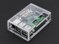 | Raspberry Pi Model B+ Case | 114990084 | $9.75
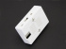 | Raspberry Pi B+ Enclosure - White | 114990124 | 4.95
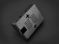 | Raspberry Pi B+ Enclosure - Black | 114990123 | $4.95
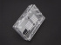 | Raspberry Pi B+ Enclosure - Transparent | 114990122 | $4.95
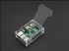 | Raspberry Pi B+ acrylic Acrylic Enclosure | 114990130 | $2.95
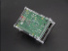 | Raspberry Pi B+ acrylic Acrylic Enclosure w/ CPU Fan | 114990129 | $7.95
 | Lightweight Buckle Wood Case - 100x80x34 mm | 325000010 | $4.90
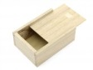 | Slider Paulownia Case - 120x85x45 mm | 325000012 | $3.50
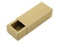 | Kraft case - 124x54x37 mm | 324000002 | $2.00
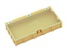 | Extra Large Size Components Storage Box - 2 PCs per lot - Yellow | TEM00200B | $3.00
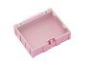 | Large Size Components Storage Box - 2 PCs per lot - Pink | TEM00100B | $2.50
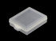 | Plastic storage box - transparent small | TEM1212AB | $0.60
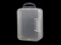 | Plastic storage box - transparent | TEM12129B | $1.00
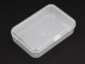 | Electronic componets box 8.8*6*2CM | 327030036 | $1.25
 | Plastic Storage Box - Multicolour | TEM12128B | $2.80
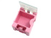 | Small Size Components Storage Box - 5 PCs per lot - red | TEM04202B | $2.00
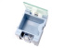 | Small Size Components Storage Box - 5 PCs per lot - blue | TEM04201B | $2.00
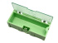 | Medium Size Components Storage Box - 5 PCs per lot - Green | TEM04101B | $5.50
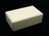 | General Plastic Case 39x63x102 mm | ACC13N32B | $4.50
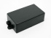 | General Plastic Case 22x37x65 mm | ACC13148B | $2.95
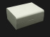 | General Plastic Case 43x79x95 mm | ACC13134B | $4.50
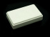 | General Plastic Case 15x35x58 mm | ACC131N5B | $2.95
 | General Plastic Case 28x44x70 mm | ACC131N9B | $3.50
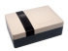 | Practical Plastic Enclosure 56x110x160 mm | ACC13132B | $7.50
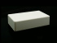 | General Plastic Case 25x60x100 mm | ACC131N7B | $3.50
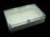 | Clear Plastic Enclosure 55x145x222 mm | ACC1319TB | $19.50
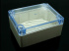 | Clear Plastic Enclosure 55x90x115mm | ACC1313TB | $12.50
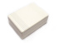 | Plastic case for small project 89*69*35mm | STR130C2B | $3.50
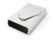 | Aluminium Case for small projects - 113*70*25 (mm) | STR103C2B | $7.50
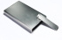 | Aluminium Case for small projects - 111*67*16 (mm) | STR127C2B | $6.50
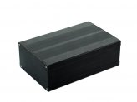 | Aluminum Case Black - 163*106*55 (mm) | ACC12241B | $10.50
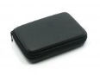 | EVA carrying case for 3G Combo | TES82800P | $4.95
 | RF Explorer EVA carrying case | ACC51924M | $4.95
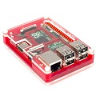 | Pibow Coupe Enclosure for Raspberry Pi Model B+ | 114110004 | $13.95
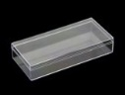 | PS(Poly Styrene) Transparent Case - 140x65x25 mm | 322060003 | $3.20
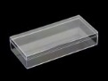 | PS(Poly Styrene) Transparent Case - 130x60x25 mm | 322060002 | $2.90
LED&Laser | Name | SKU | Price
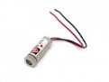 | 5mW Laser Module emitter - Red Line | IRL103A2B | $4.90
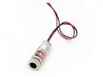 | 5mW Laser Module emitter - Red Point | IRL104A2B | $4.90
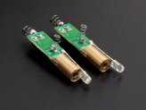 | Laser+LED 2 in 1 module | 114990184 | $1.50
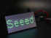 | P3 64x32 RGB LED Matrix - 196x96mm | 104990162 | $69.95
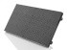 | P4 64x32 RGB LED Matrix - 256x128mm | 104990161 | $68.00
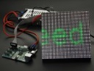 | Dual P5 32x32 RGB LED Matrix - 160x160mm | 104990165 | $41.50
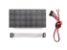 | Dual P6 32x16 RGB LED Matrix - 192x96mm | 104990159 | $35.00
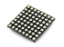 | 8x8 RGB LED Matrix - Square LED Dot | 800135001 | $11.90
 | Ultrathin 16x32 Red LED Matrix Panel | DIS07191M | $19.50
 | 32mm 8x8 Square Matrix LED - Red Common Anode | 104990138 | $2.50
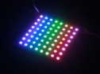 | 8*8 RGB LED Matrix w/ WS2812B - DC 5V | 104990129 | $29.50
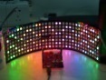 | 8x32 RGB LED Matrix w/ WS2812B - DC 5V | 104990128 | $89.00
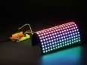 | 16x16 RGB LED Matrix w/ WS2812B - DC 5V | 104990127 | $89.00
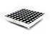 | 60mm square 8*8 LED Matrix - Bi-Color Red/Green | LED203A5B | $5.50
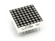 | 20mm 8*8 square matrix LED - Red | LED201A5B | $2.25
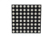 | 8x8 RGB LED Dot Matrix - Compatible with Rainbowduino | LED204A5B | $9.90
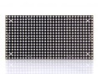 | Ultrathin 16x32 RGB LED Matrix Panel | 104990094 | $38.90
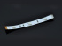 | 3W RGB LED strip common anode 12V | LED415B7B | $3.50
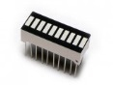 | 10 segment LED gauge bar | LED207A6B | $1.50
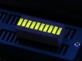 | 10 Segment LED - Yellow Green | 104990112 | $1.45
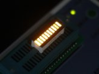 | 10 Segment LED - Yellow | 104990111 | $1.45
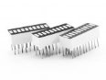 | 10 Segment LED - Green | 104990108 | $1.45
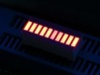 | 10 Segment LED - Red | 104990109 | $1.45
 | 10 Segment LED - White | 104990110 | $1.50
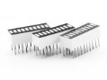 | 10 Segment LED – Blue | 104990107 | $1.50
 | 10 Segment LED – Amber | 104990106 | $1.45
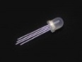 | 8mm RGB Led lamp common anode (10 PCs) | LED705A1B | $5.90
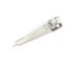 | 5mm Triple Output LED RGB - Common Anode (20 PCs) | LED105A2B | $5.00
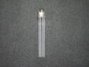 | 5mm Triple Output LED RGB - Common cathode (20 PCs) | LED106A2B | $5.00
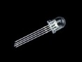 | 8mm RGB Led lamp common Cathode (10 PCs) | 800003001 | $5.90
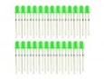 | 3mm LED Green - 25 PCs | LED07222B | $1.50
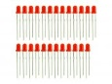 | 3mm LED Red - 25 PCs | LED07223B | $1.50
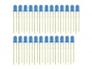 | 3mm LED Blue - 25 PCs | LED07221B | $1.50
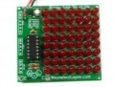 | Blinky Grid Red | KIT03281M | $24.50
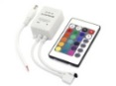 | RGB Controller | TEM03018B | $5.50
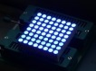 | 38mm 8x8 square matrix LED - Blue Common Anode | 104990126 | $4.95
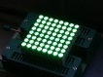 | 38mm 8x8 square matrix LED - Green Common Anode | 104990125 | $4.95
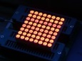 | 38mm 8x8 square matrix LED - Red Common Anode | 104990124 | $2.95
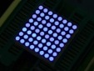 | 32mm 8x8 Square Matrix LED Blue - Common Anode | 104990135 | $4.75
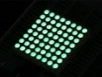 | 32mm 8x8 Square Matrix LED Green - Common Anode | 104990136 | $4.75
 | 32mm 8x8 Square Matrix LED Amber - Common Anode | 104990137 | $2.25
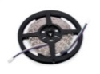 | Flexible LED Strip - RGB | TEM03013B | $14.90
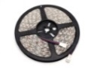 | Flexible Waterproof LED Strip - RGB | TEM03014B | $15.90
 | WS2812B Digital RGB LED Waterproof Flexi-Strip 144 LED/meter - 2 meter | 104990090 | $139.00
 | WS2812B Digital RGB LED Flexi-Strip 144 LED - 1 Meter | 104990089 | $69.00
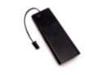 | EL wire 2xAA pocket inverter | TEM03072B | $4.50
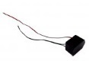 | Robust EL Inverter For EL Shield | POW10301P | $8.50
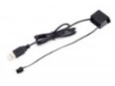 | EL USB Inverter | TEM04252B | $4.50
 | Flexible Waterproof LED Strip - Red | TEM03012B | $15.90
 | Flexible LED Strip - Red | TEM03011B | $14.90
 | Flexible LED Strip - Yellow | TEM03021B | $14.90
 | Flexible LED Strip - Blue | TEM03031B | $14.90
 | Flexible LED Strip - Green | TEM03041B | $14.90
 | Flexible LED Strip - White | TEM03051B | $14.90
 | Flexible Waterproof LED Strip - Yellow | TEM03071B | $15.90
 | Flexible Waterproof LED Strip - Blue | TEM03081B | $15.90
 | Flexible Waterproof LED Strip - Green | TEM03091B | $15.90
 | Flexible Waterproof LED Strip - White | TEM03101B | $15.90
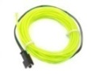 | EL Wire-Green 3m | TEM03046B | $8.50
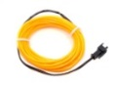 | EL Wire-Yellow 3m | TEM03026B | $8.50
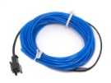 | EL Wire-Blue 3m | TEM03036B | $8.50
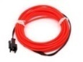 | EL Wire-Red 3m | TEM03016B | $8.50
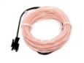 | EL Wire-White 3m | TEM03056B | $8.50
 | EL Tape - Red 1m | TEM05141B | $5.40
 | EL Tape - Green 1m | TEM05143B | $5.40
 | EL Tape - Blue 1m | TEM05144B | $5.40
 | EL Tape - White 1m | TEM05145B | $5.40
 | EL Tape - Yellow 1m | TEM05142B | $5.40
 | EL Panel - Yellow 10cm x 10cm | TEM05147B | $8.90
 | EL Panel - Red 10cm x 10cm | TEM05146B | $8.90
 | EL Panel - Blue 10cm x 10cm | TEM05149B | $8.90
 | EL Panel - White 10cm x 10cm | TEM0514AB | $8.90
 | EL Panel - Green 10cm x 10cm | TEM05148B | $8.90
 | EL Panel - Light Blue 10cm x 10cm | TEM0514BB | $8.90
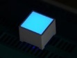 | 15*15mm LED Square - Blue | 104990099 | $1.95
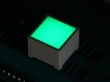 | 15*15mm LED Square - Green | 104990098 | $1.90
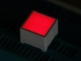 | 15*15mm LED Square - Red | 104990097 | $1.90
 | 7 Segment Display - 3 Inches - Red | TEM0514CB | $3.90
 | 7 Segment Display - 5 Inches - Red | TEM0514DB | $6.90
 | 7 Segment Display - 8 Inches - Red | TEM0514EB | $8.90
 | 7 Segment Display - 3 Inches - Green | TEM06271B | $3.90
 | 7 Segment Display - 5 Inches - Green | TEM06272B | $6.90
 | 7 Segment Display - 8 Inches - Green | TEM06273B | $8.90
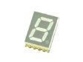 | Single Digit 7 Segment SMD Display | TEM01161B | $0.90
 | 0.8 Inch 16 Segment LED Amber - Common Anode | 104990134 | $1.85
 | 0.8 Inch 16 Segment LED Blue - Common Anode | 104990133 | $1.95
 | 0.8 Inch 16 Segment LED Green - Common Anode | 104990131 | $1.95
 | 0.8 Inch 16 Segment LED Yellow - Common Anode | 104990132 | $1.85
 | 0.8 Inch 16 Segment LED White - Common Anode | 104990130 | $1.95
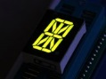 | 0.8 Inch 16 Segment LED Yellow Green - Common Anode | 104990120 | $1.95
 | 0.8 Inch 16 Segment LED Red - Common Cathode | 104990119 | $1.50
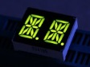 | Dual Alphanumeric 14 Segment LED - Yello Green 0.54 inch | 104990123 | $1.50
 | Dual Alphanumeric 14 Segment LED - Amber 0.54 inch Common Cathode | 104990121 | $1.95
 | Dual Alphanumeric 14 Segment LED - Red 0.54 inch | 104990122 | $1.50
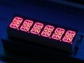 | Six Alphanumeric 14 Segment LED - Red | 104990117 | $2.50
 | Chainable RGB LED - 40 LEDs /Unit | TEM02051B | $34.90
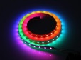 | Digital RGB LED Flexi-Strip 30 LED - 1 Meter | 800020001 | $9.90
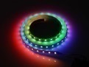 | Digital RGB LED Flexi-Strip 60 LED - 1 Meter | 800021001 | $16.90
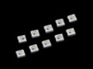 | WS2812B RGB LED with Integrated Driver Chip (10 PCs pack) | 800052001 | $3.90
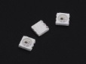 | WS2812S RGB LED with Integrated Driver Chip (10 PCs pack) | 104990151 | $3.90
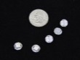 | WS2812B LED Breakout Board | 104990139 | $1.45
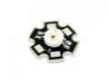 | Luxeon III Star compatible - 3Wl super light RGB LED | LED411A2B | $8.50
Wire | Name | SKU | Price
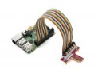 | Raspberry Pi B+ 40pin to 26pin Cable | 321070032 | $2.75
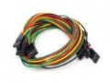 | 4 pin dual-female jumper wire - 300mm (5 PCs pack) | CAB104C4O | $3.00
 | Copper Foil Paper - 30m | 114990068 | $2.55
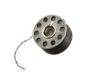 | Conductive Stainless Steel Sewing Thread - 22 Meter/72ft | 816000100 | $3.50
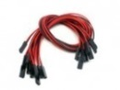 | 2 pin dual-female jumper wire - 300mm （10 PCs pack) | CAB103C4O | $4.50
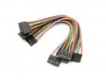 | 8 pin dual-female jumper cable- 150mm (5 PCs pack) | CAB109C4O | $5.00
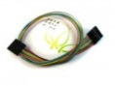 | 6 pin dual-female jumper wire - 300mm (5 PCs pack) | CAB107C4O | $3.50
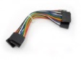 | 6 pin dual-female jumper wire - 100mm (5 PCs pack) | CAB106C4O | $3.00
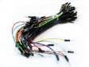 | Breadboard Jumper Wire Pack(200mm/165mm/125mm/80mm) | CAB110C4M | $5.00
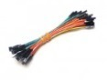 | 1 pin dual-female jumper wire 100mm 50pcs pack | CAB102C4O | $4.99
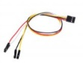 | 4 pin to 4 separated pins female jumper wire-300mm (5 PCs pack) | CAB105C4O | $4.00
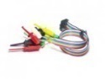 | Bus Pirate v3 probe Kit | THM199C4M | 4.99
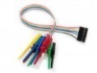 | Open logic sniffer probe cable | OBC102E2O | $6.00
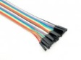 | 20 pin dual female splittable jumper wire - 300mm | CAB115C3O | $2.99
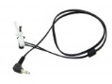 | Spare probe for DSO Nano | TOL124D5O | $1.50
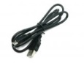 | Mini USB cable 100cm | ARD112C5B | $2.00
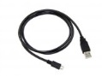 | Micro USB Cable - 100cm | HOK05173P | $2.90
 | Micro USB Cable - 48cm | HOK05172P | $2.50
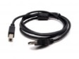 | Type-B USB cable for Arduino Diecimila and Freeduino | ARD115C4B | $1.95
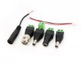 | Power converter 6 in 1 pack | CNE112D1P | $3.50
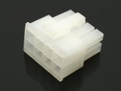 | Eight pin connector | ACC39949M | $1.50
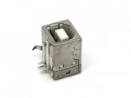 | USB Female Type B Connector | CNE105B3B | $0.30
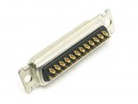 | Sixteen Channel Driver Channel Connector | ACC48955M | $2.99
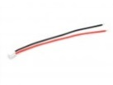 | JST 2 Pin power connector | ARD110C4M | $0.10
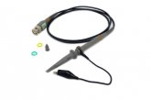 | BNC Oscilloscope Probe - 100MHZ | TOL130B2B | $17.50
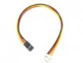 | Grove - Electronic brick 3 pin to Grove 4 pin converter cable (5 PCs pack) | ELE103C4O | $4.50
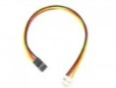 | Grove - Electronic brick 4 pin to Grove 4 pin converter cable (5 PCs pack) | ACC05221P | $2.90
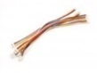 | Grove - Universal 4 Pin 20cm Unbuckled Cable (5 PCs Pack) | ACC11317O | $2.90
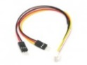 | Grove - Branch Cable for Servo(5PCs pack) | ACC12159O | $4.90
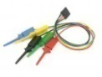 | Logic Shrimp probe cable | TES12452P | $3.99
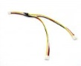 | Grove - Branch Cable (5PCs pack) | ACC53059P | $3.90
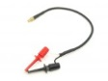 | Digital probe for DSO Quad | ACC53193P | $2.90
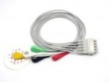 | 5 lead ECG cable - Marquette Compatible | MED60320M | $49.90
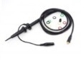 | MCX Probe Kit (X1 X10) for DSO Quad | ACC60709M | $19.90
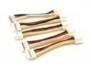 | Grove - Universal 4 Pin Buckled 5cm Cable (5 PCs Pack) | ACC83054O | $1.90
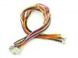 | Grove - Universal 4 Pin Buckled 30cm Cable (5 PCs Pack) | ACC83055O | $2.90
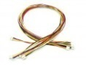 | Grove - Universal 4 Pin Buckled 40cm Cable (5 PCs Pack) | ACC83056O | $3.90
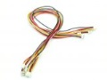 | Grove - Universal 4 Pin Buckled 50cm Cable (5 PCs Pack) | ACC83057O | $3.90
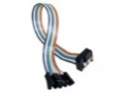 | Bus Pirate Cable | ACC90144P | $4.29
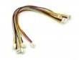 | Grove - Universal 4 Pin Buckled 20cm Cable (5 PCs pack) | ACC90453O | $2.90
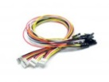 | Grove - 4 pin Female Jumper to Grove 4 pin Conversion Cable (5 PCs per PAck) | ACC17112O | $3.90
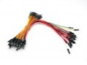 | Breadboard Jumper Wire Pack(200mm/100mm) | PRO12706O | $7.50
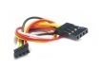 | 4 pin 2.54mm to 2.0mm Female jumper wire -100mm (5PCs pack) | CAB113C4O | $3.00
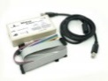 | DSJTAG - 2 in 1 USB JTAG cable for FPGA/CPLD | TES12995M | $54.90
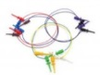 | Probe jumper wire – 8pcs | CAB01101M | $4.00
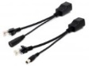 | Passive PoE Cable Set | TEM04251B | $4.50
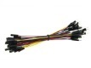 | 1 Pin Female-Male Jumper Wire 125mm (50pcs pack) | ACC12242B | $4.99
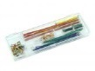 | Breadboard Jumper Wire Set (140 PCs Pack) | CAB01200O | $3.90
 | Multicolor Tie Wraps | TEM12281B | $4.90
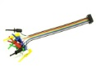 | Bus Pirate v4 Probe Kit | ACC06042B | $4.99
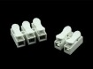 | Wire Connector Set | TEM01042B | $1.00
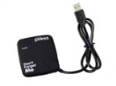 | USB Hub | HOK06052B | $4.90
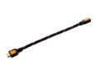 | 0.3M HDMI to HDMI male lead cable | HOK06062B | $2.90
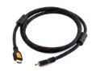 | 1.5M HDMI to HDMI male lead cable | HOK06063B | $3.50
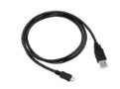 | HDMI Male to Micro HDMI Male Cable - 1.5m | HOK06181B | $4.50
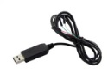 | USB to TTL Serial Cable - Debugger for Dev Board | 359313001 | $5.50
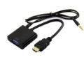 | HDMI to VGA Adapter | 349059001 | $9.90
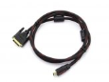 | HDMI to DVI Adapter | 109990051 | $5.50
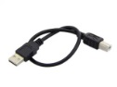 | USB Cable Type A to B - 30CM Black | 351010001 | $1.95
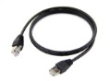 | Black Ethernet Cable - 1 Meter | 352002001 | $2.50
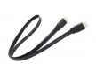 | Flat HDMI Male to Male Cable 1M,Support 3D For HDTV computer & tablets cable | 109990056 | $3.95
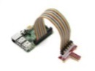 | Raspberry Pi B+ 40pin to 26pin Cable | 321070032 | $2.75
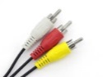 | 3.5 mm Jack to 3 RCA Adapter Cable - 150mm | 321030002 | $2.90
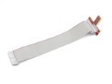 | Breakout Kit for Raspberry Pi B w/ 40pin to 26pin Cable | 110990439 | $7.95
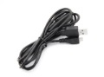 | Micro USB Cable w/ Switch | 109990054 | $2.95
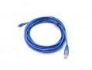 | Micro USB Cable - 5m | 114990141 | $4.50
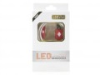 | Micro USB Cable w/ LED | 109990053 | $2.25
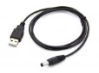 | USB 2.0 to DC 5.5mm Cable - 100cm | 321010017 | $2.45
 | USB 2.0 to DC 3.5mm Cable - 100cm | 321010018 | $2.45
 | USB 2.0 to DC 2.5mm Cable - 100cm | 321010019 | $2.45
 | USB 2.0 to DC 2.0mm Cable - 100cm | 321010020 | $2.45

Display | Name | SKU | Price
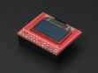 | Raspberry Pi 0.96” OLED Display Module | 317080006 | $24.50
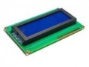 | LCD 20*4 Characters - White back light | LCD108B6B | $9.90
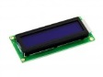 | LCD 16x2 Characters - White Text Blue Background | 800002001 | $8.90
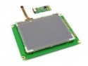 | 320*240 graphic LCD w/ Touch Screen and HW accel. | LCD105B6B | $89.90
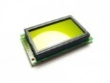 | Graphic LCD 128*64 (KS0108 ctrl) - D.Blue and Yellow Green | LCD102B6B | $21.50
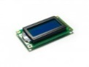 | LCD 8*2 Characters - Blue back light | LCD104B6B | $5.95
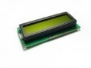 | LCD 16*2 Characters - Green Yellow back light | LCD103B6B | $7.95
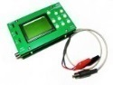 | Digital Storage Oscilloscope with Panels | TOL106C3M | $48.00
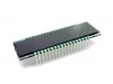 | Omni purpose multi-segment TN LCD | TEM03151B | $8.70
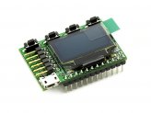 | XMEGA Xprotolab | TES12273O | $49.00
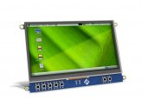 | 7" LCD Cape for Beagle Bone Black - Touch Display | 800055001 | $89.00
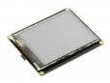 | 2.8" USB TFT Display Module For Raspberry Pi | 800059001 | $45.50
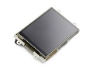 | 3.2” Primary Display for Raspberry Pi | 104110001 | $45.00
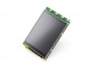 | 3.2 Inch TFT LCD Screen for Raspberry Pi | 104990163 | $34.95
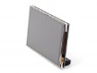 | 3.5 Inch TFT Display for Raspberry Pi - Resistive Touch Screen | 308010014 | $27.50
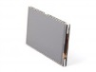 | 4 Inch TFT Display for Raspberry Pi - Resistive Touch Screen | 308010015 | $44.95
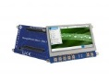 | 4.3'' LCD Cape for BeagleBone Black ‐ Touch Display | LCD00700B | $59.00
 | 10.1''LCD Display - 1366x768 HDMI/VGA/NTSC/PAL | DIS00200M | $89.00
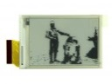 | 2.7'' e-Paper Panel | LCD00200B | $25.90
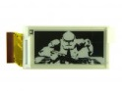 | 2.0'' e-Paper Panel | LCD00300B | $19.90
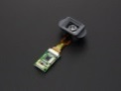 | LightView 201k Digital display module | 104990164 | $68.95
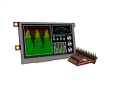 | 4.3” Raspberry Pi Display Module | 104110004 | $139.00
RF(RFID) | Name | SKU | Price
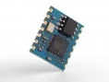 | WiFi Serial Transceiver Module w/ ESP8266-Medium | 113990085 | $6.95
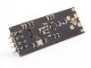 | 2.4G wireless module NRF24L01+PA+LNA (PA-SMA) | 317990025 | $9.90
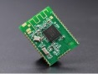 | PTR9022 Multiprotocol ANT/BLE Module embedded ARM Cortex | 113990106 | $6.68
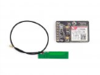 | LoNet - Mini GSM/GPRS Breakout | 109990071 | $24.95
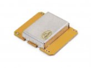 | Doppler X band Radar detector sensor module 10.525GHz | 317990023 | $8.90
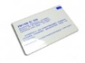 | M1 RFID card (13.56Mhz) | RFR104A1B | $2.00
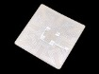 | 13.56MHz RFID book tag | SEN01161B | $1.50
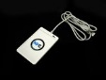 | NFC Smart Card Reader | SEN127ACM | $69.00
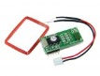 | 125Khz RFID module - UART | RFR101A1M | $12.50
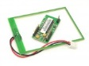 | 13.56Mhz RFID module - IOS/IEC 14443 type a | RFR105A1M | $29.50
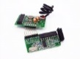 | 2KM Long Range RF link kits w/ encoder and decoder | WLS102B5B | $18.00
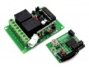 | 315Mhz remote relay switch kits - 2 channels | WLS103B5B | $19.50
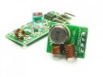 | 315Mhz RF link kit | WLS105B5B | $4.90
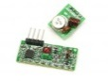 | 433Mhz RF link kit | WLS107B4B | $4.90
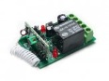 | 315MHz Codec-Adaptive Wireless Relay | WLS120B5B | $8.90
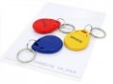 | RFID tag combo (125khz) - 5 pcs | RFR103B2B | $2.50
 | M1 RFID Tag (13.56MHz) | SEN82328P | $2.00
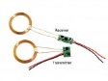 | Wireless Charging Module | POW01141B | $7.90
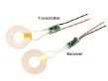 | Wireless Charging Module - 5V/1A | 106990017 | $8.50
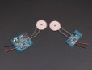 | Smart Wireless Charger Transmitter - 5V/1.5A | 317010007 | $24.50
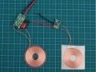 | Smart Wireless Charger Transmitter - 5V/0.6A | 317010006 | $9.50
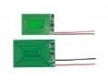 | Wireless Charging PCB Module 5-12V | 106990018 | $7.90
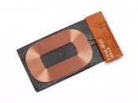 | Qi General Wireless Charger Receiver - 5V/0.5A | 317010008 | $8.95
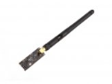 | 2.4G wireless module NRF24L01+PA+LNA (PA-IPX) | 317990024 | $9.90
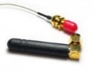 | GSM(900/1800) antenna with interface cable | WLS119E1B | $6.50
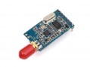 | 433/868/915MHz Ultra low power data radio module | 317010010 | $19.50
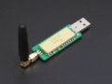 | Wireless communication module for any device supports USB | 317990016 | $82.00
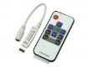 | RF Mini RGB Controller | TEM01181B | $9.90
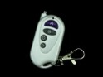 | 433MHz 4-Button Car Key Fob | WLS03132B | $2.90
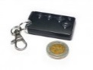 | 315Mhz Wireless car key fob with key chain (battery included) | WLS118B5B | $6.50
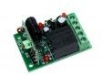 | 433MHz Codec-Adaptive Wireless Relay | WLS03133B | $8.90
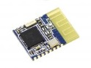 | Bluetooth V4.0 HM-11 BLE Module | 210005001 | $12.90
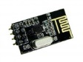 | nRF24L01+Module | WLS03134B | $2.90
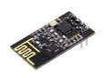 | nRF24L01+ Module - Enhanced Edition | 800115001 | $6.90
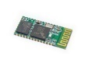 | Serial port bluetooth module (Master/Slave) | WLS123A1M | $21.50
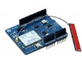 | WizFi Shield | SLD03191B | $55.00
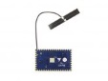 | Dragino HE-open source wifi,Linux Hardware | 317060006 | $18.80
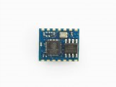 | WiFi Serial Transceiver Module w/ ESP8266 - Small | 113990084 | $6.95
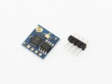 | WiFi Serial Transceiver Module Breakout Board w/ ESP8266 | 113990080 | $6.95
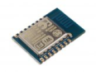 | ESP8266 based WiFi module FCC/CE | 317060011 | $7.50
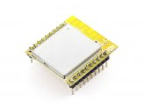 | 2.4GHz Micropower ZigBee Wireless module | 317990015 | $24.95
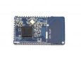 | low power consumption BLE4.0 module with 2.4GHz PCB antenna16*28mm | 317030014 | $11.50
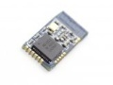 | Low power consumption BLE4.0 module with 2.4GHz PCB antenna 18.5*9.1mm | 317030015 | $11.50
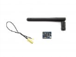 | MT7681 WiFi module | 114990086 | $11.50
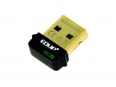 | 802.11b/g/n 150Mbps Wireless USB Adapter | WLS06051B | $8.90
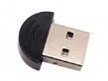 | Bluetooth USB Dongle | ACC08275B | $3.90
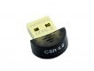 | Bluetooth CSR4.0 USB Dongle | TEM12243B | $9.90
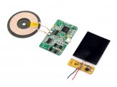 | QI Wireless Charging Module Kit - 5V/1A | 800123001 | $19.80
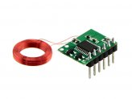 | Mini 125Khz RFID Module - Pre-Soldered Antenna (35mm Reading Distance) | 800125001 | $9.90
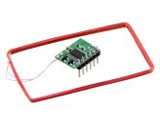 | Mini 125Khz RFID Module - Pre-Soldered Antenna (70mm Reading Distance) | 800126001 | $9.90
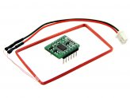 | Mini 125Khz RFID Module - External LED/Buzzer Port (70mm Reading Distance) | 800124001 | $10.50
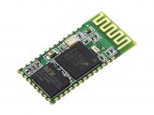 | Bluetooth V2.0 Serial Transceiver Module - 3.3V | 800133001 | $9.90
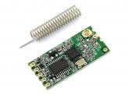 | 434Mhz Wireless Serial Transceiver Module - 40 Meters | 800131001 | $8.90
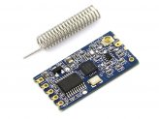 | 433Mhz Wireless Serial Transceiver Module - 1 Kilometer | 800132001 | $12.90
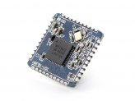 | 2.4GHz low power consumption BLE4.0 module (not include antenna) 16*16mm | 317030013 | $10.75
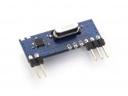 | 315MHz ASK/OOK Super-heterodyne Receiver module | 317020002 | $3.75
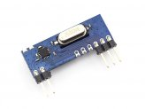 | 433MHz ASK/OOK Super-heterodyne Receiver module | 317020003 | $3.75
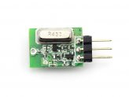 | 433MHz ASK/OOK Transmitter module | 317010005 | $3.75
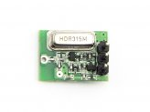 | 315MHz ASK/OOK Transmitter module | 317010004 | $3.75
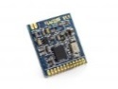 | 433MHz wireless ISM transceiver module | 317010003 | $8.90
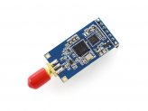 | 420-450MHz Ultra low power data radio module | 317010009 | $19.50
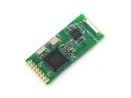 | 2.4GHz Bluetooth Low Energy 4.0 module-20dB V-14004 | 317030018 | $19.95
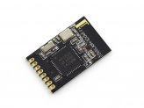 | 2.4GHz Bluetooth Low Energy 4.0 module-4dB V-14001 | 317030017 | $14.95
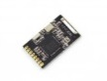 | 2.4GHz Bluetooth Low Energy 4.0 module-4dB V-13051 | 317030016 | $15.95
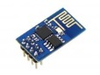 | WiFi Serial Transceiver Module w/ ESP8266 | 114990085 | $6.95
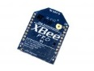 | XBee Pro PCB Antenna - S1 (DigiMesh 2.4) | WLS07032M | $39.90
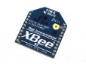 | XBee PCB Antenna - S1 (802.15.4) | WLS07031M | $27.90
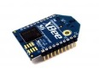 | XBee Wi-Fi PCB Antenna - S6 | WLS03205M | $59.50
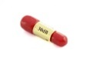 | 6GHz 2W SMA Attenuator - 30dB | 320160017 | $24.95
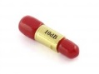 | 6GHz 2W SMA Attenuator - 10dB | 320160016 | $24.95
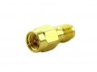 | RF Adapter RP-SMA Jack to SMA Plug straight-long version | ACC08278P | $4.00
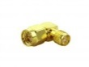 | SMA adapter SMA Plug to SMA Jack right angle | ACC08279P | $4.50
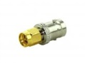 | SMA-BNC adapter SMA Plug to BNC Jack straight | ACC08280P | $4.50
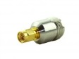 | SMA-N adapter SMA Plug to N Jack straight | ACC08275P | $5.90
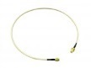 | 50cm length - SMA male to SMA female RF pigtail Coxial Cable RG316 | ACC08276P | $9.50
 | 50cm length - SMA male to SMA male plug pigtail cable RG316 | ACC08277P | $9.90
Motor | Name | SKU | Price
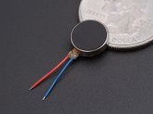 | Mini vibration motor 2.0mm | 316040001 | $1.20
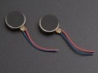 | Mini vibration motor 2.7mm | 316040004 | $1.20
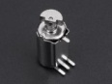 | Mini vibration motor SMD | 316040005 | $1.20
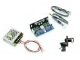 | Galvanometer motor (SC17-15K) | 316010012 | $69.95
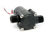 | 3.6V Micro hydro generator | POW109D3B | $25.00
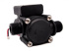 | 3.6V Micro Hydro Generator Pro | TEM09291B | $33.00
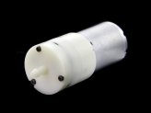 | 6V Mini Vacuum Pump | 114990075 | $14.50
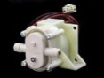 | 12V DC Water Pump | 114990072 | $15.90
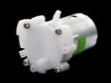 | 6V Mini Water Pump | 114990073 | $6.90
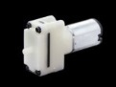 | 3V Mini Vacuum Pump | 114990074 | $3.50
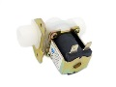 | G1/2 Electric Solenoid Valve (Normally Open) | SWT11191B | $9.90
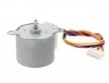 | Small Size and High Torque Stepper Motor - 35BYJ412 | 800182001 | $13.50
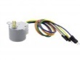 | Small Size and High Torque Stepper Motor - 24BYJ48 | 800181001 | $4.50
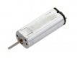 | K30 DC 20000RPM DC Motor | 114990071 | $2.50
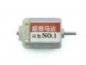 | 130 DC Motor | 316030010 | $2.55
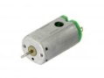 | N30 3V DC 12000RPM DC Motor | 800190001 | $1.95
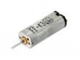 | K30 3V DC 12000RPM DC Motor | 800189001 | $1.90
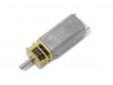 | Geared Motor GA13YN050 | 316070004 | $9.50
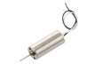 | 3.7V 50000RPM Small Coreless Motor 716 | 800179001 | $1.95
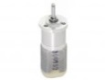 | Planet Geared Motor F280 | 316070006 | $6.50
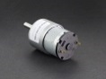 | Encoder Geared Motor ASLONG-JGB37-520（107RPM) | 108990017 | $9.95
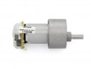 | Encoder Geared Motor JGB37-371 | 316070003 | $15.00
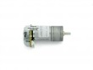 | Encoder Geared Motor JGA25-371 | 316070002 | $14.95
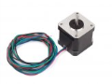 | Stepper Motor YH42BYGH40-402A | 114990134 | $15.50
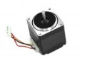 | Step Motor 28H2P3205A4 | 316020002 | $14.95
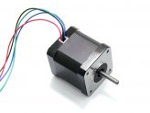 | Step Motor 42BYGH47-401A | 316020003 | $14.50
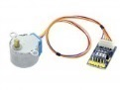 | Gear Stepper Motor with Driver | 241003001 | $6.90
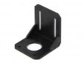 | 42 Step Motor Frame - Black | 323030011 | $4.95
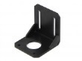 | 57 Step Motor Frame - Black | 323030012 | $4.95
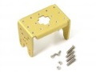 | Driving arm Connection for Servo motor | 316010010 | $9.90
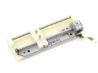 | B04F 5V DC 18° Stepper Motor | 800180001 | $14.90
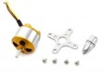 | Emax XA2212 12V DC 1400KV Brushless Motor | 800188001 | $18.95
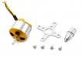 | Emax XA2212 12V DC 980KV Brushless Motor | 800187001 | $18.95
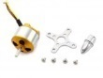 | Emax XA2212 12V DC 820KV Brushless Motor | 800186001 | $18.95
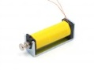 | DC framework miniature solenoid VL-0063 | COM12292B | $5.80
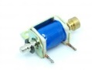 | DC framework solenoid HCNE1-0416 | COM12293B | $10.20
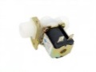 | G1/2 Electric Solenoid Valve (Normally Closed) | SWT133B2B | $8.50
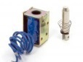 | DC framework solenoid HCNE1-0630 | COM12294B | $9.95
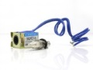 | DC framework solenoid HCNE1-0520 | COM62158M | $5.95
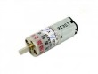 | Gear Motor 6V 60rpm - Dustproof | MOT114A1B | $7.90
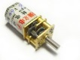 | Gear (reduction ) motor p12 6V 60RPM | MOT102A2B | $6.90
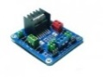 | L298 Dual H-Bridge Motor Driver | MOT103B1M | $23.50
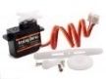 | Grove - Servo | ROB08211P | $9.90
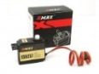 | EMAX ES9257 2.5kg/ .05 sec Micro Digital 3D Tail Servo | ROB12956M | $24.90
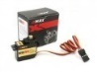 | EMax 12g ES08MD high Sensitive servo | ROB12853M | $21.90
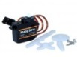 | EMAX 9g ES08A High Sensitive Mini Servo | ROB12745M | $9.90
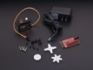 | Tessel Servo Module | 108990016 | $25.00
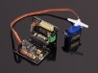 | SoftServo-B10CH (Servo Controller/ RC Signal Generator) | 105990022 | $16.00
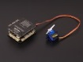 | ManShow-RC1 (Robot Controller) | 102990169 | $37.00
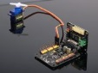 | SoftServo-B24CH (Servo Controller / RC Signal Generator ) | 105990023 | $26.00
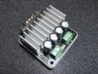 | Booster-B24V2A5(Brushed DC Motor Controller/Dual H-bridge ) | 105990025 | $39.00
 | Booster-B36V2A5(Brushed DC Motor Controller/Dual H-bridge ) | 105990026 | $49.00
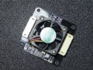 | GDD-FAN1(Fan for Gicren's high-power device) | 114990181 | $13.00
Board | Name | SKU | Price
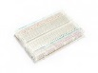 | Bread board Clear - 8.2 x 5.3cm | STR101C2M | $5.50
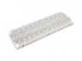 | Basic Bread board - 16.5*5.5 cm | STR102C2M | $6.90
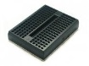 | Mini Bread board 4.5x3.5CM-Black | STR118C2M | $2.95
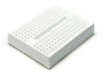 | Mini Bread board 4.5x3.5CM-White | STR122C2M | $2.95
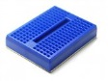 | Mini Bread board 4.5x3.5CM-Blue | STR119C2M | $2.95
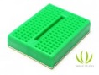 | Mini Bread board 4.5x3.5CM-Green | STR120C2M | $2.95
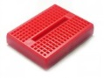 | Mini Bread board 4.5x3.5CM-Red | STR121C2M | $2.95
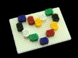 | Tiny Bread Board Kit | TEM03291B | $7.90
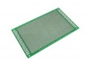 | ProtoBoard 9cm * 15cm - 2.0mm | TOL105C2B | $3.50
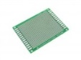 | ProtoBoard 6cm * 8cm - 2.0mm | STR132C2B | $2.50
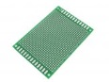 | ProtoBoard 7cm * 10cm - 2.54mm | STR125C2B | $2.50
Camera | Name | SKU | Price
 | USB Infrared Camera | 114990128 | $14.50
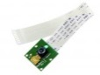 | Raspberry Pi Camera Module | 800027001 | $29.90
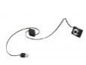 | 300K Pixel USB 2.0 Mini Webcam | SEN06053B | $8.90
Voltmeter& Converter | Name | SKU | Price
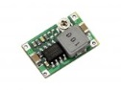 | Adjustable Step-Down DC/DC Converter (1.0V - 17V/1.8A) | 800120001 | $3.90
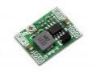 | Adjustable Step-Down DC/DC Converter (0.8V - 18V/3A) | 800121001 | $4.50
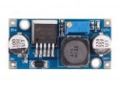 | Adjustable DC/DC Power Converter (1.25V - 35V/3A) | POW00900M | $3.90
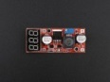 | Adjustable DC/DC Power Converter with LED segment display(4.5V - 28V/1.5A) | 114990167 | $7.50
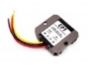 | CPT-C5 power converter 12V/24V switch to 5V | POW01161B | $8.50
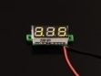 | 0.28 inch LED digital DC voltmeter – Yellow | 114990165 | $2.45
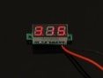 | 0.28 inch LED digital DC voltmeter – Red | 114990164 | $2.45
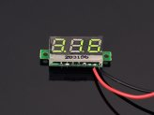 | 0.28 inch LED digital DC voltmeter - Green | 114990163 | $2.45

Adapter | Name | SKU | Price
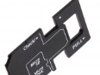 | Micro SD(HC) 3-In-1 Card Reader | 112990005 | $7.50
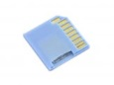 | Micro SD Card Adapter for Raspberry & Macbooks - Blue | 830061001 | $2.90
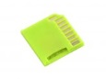 | Micro SD Card Adapter for Raspberry & Macbooks - Green | 830060001 | $2.90
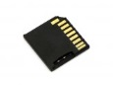 | Micro SD Card Adapter for Raspberry & Macbooks - Black | 830059001 | $2.90
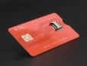 | Micro SIM card converter | 114990176 | $8.00
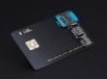 | 3in1 Micro/Nano/Standard SIM card converter | 114990175 | $19.50
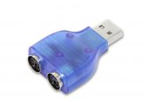 | PS/2 to USB Adapter | 109990052 | $1.95
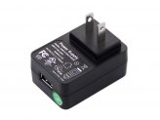 | American Standard USB Wall Power Supply 5VDC 2.1A - FCC UL | 279011001 | $6.95
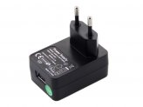 | Europe Standard USB Wall Power Supply 5VDC 2.1A - CE Intertek GS | 279010001 | $6.95
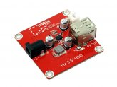 | 3.5" HDD Addon Package | 800117001 | $8.90
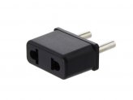 | Euro Plug Power Adapter | 341051001 | $1.95
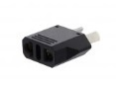 | Australian Plug Power Adapter | 341049001 | $1.95
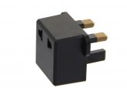 | UK Plug Power Adapter | 341050001 | $1.95
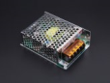 | 12V5A Power adapter | 106990023 | $7.90
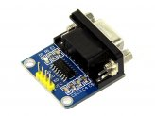 | RS232 to TTL Converter Module | 800058001 | $2.90
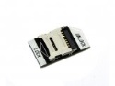 | MicroSD Card Adapter for Raspberry Pi | 800051001 | $3.90
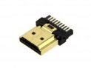 | Bare HDMI Male Connector | 349057001 | $1.90
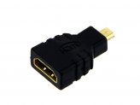 | Micro HDMI to HDMI Adapter | 349058001 | $2.90
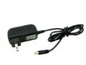 | Wall Adapter Power Supply - 12VDC 1A | POW06184B | $3.90
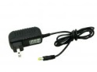 | Wall Adapter Power Supply - 9VDC 1A | POW06183B | $3.90
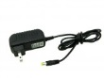 | Wall Adapter Power Supply - 5VDC 2A | POW06182B | $3.90
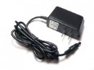 | Wall Adapter Power Supply - 6.5VDC 2A | TOL113C3O | $4.90
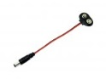 | 9V to Barrel Jack Adapter | POW05231B | $0.50
Battery | Name | SKU | Price
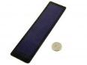 | 2V 0.5W Thin-film Flexible Solar Panel | 800196001 | $7.50
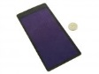 | 2V 1W Thin-film Flexible Solar Panel | 800197001 | $13.50
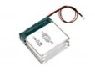 | Polymer Lithium Ion Battery - 6600mAh 3.7V | 270021001 | $24.90
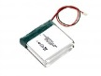 | Polymer Lithium Ion Battery - 4400mAh 3.7V | 270020001 | $17.90
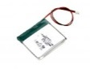 | Polymer Lithium Ion Battery - 2200mAh 3.7V | 270019001 | $9.90
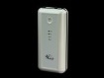 | Power Bank - 5,000mAh | POW00800M | $19.90
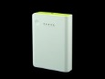 | Power Bank - 10,000mAh | POW00400P | $29.90
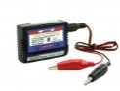 | 2-3S Li-Poly Battery Charger | POW01200M | $8.90
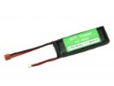 | Polymer Lithium Ion Battery - 2200mAh 11.1V | POW00200P | $16.90
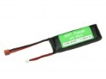 | Polymer Lithium Ion Battery - 2200mAh 7.4V | POW00300P | $13.90
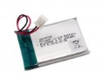 | RF Explorer Replacement Battery | POW11071P | $7.50
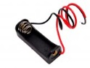 | 12V 23A Battery Holder Case | TEM09242B | $0.50
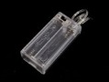 | 2 x AA Battery Holder with On/Off Switch and Slider Cover | POW03291B | $0.60
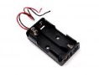 | 2xAA Battery Holder | POW03191B | $0.50
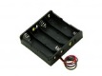 | 4xAA Battery Holder | POW00600M | $1.50
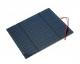 | 3W Solar Panel 138X160 | POW92136O | $11.95
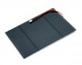 | 2.5W Solar Panel 116X160 | POW92145O | $9.95
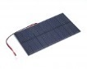 | 1.5W Solar Panel 81X137 | POW92152O | $5.95
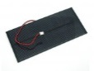 | 2W Solar Panel 80X180 | POW81652O | $7.95
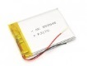 | DSO Nano v2 replacement battery | POW108C1M | $5.50
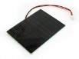 | 1W Solar Panel 80X100 | POW111D2P | $3.95
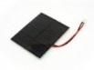 | 0.5W Solar Panel 55x70 | POW112D2P | $1.95
Development Kit | Name | SKU | Price
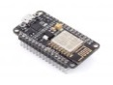 | NodeMCU v2 - Lua based ESP8266 development kit | 113990105 | $12.95
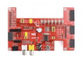 | DVK570 Shield for Cubietruck | 103110001 | $29.50
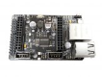 | WRTnode Standard Shield | 114990197 | $12.95
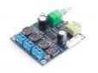 | Audio Amplifier Module A25 | 317990019 | $12.00
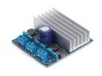 | Audio Amplifier Module A40 | 317990020 | $15.00
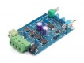 | Audio Amplifier Module B25 | 317990021 | $15.00
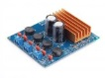 | Audio Amplifier Module A80 | 317990022 | $20.00
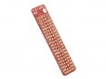 | Raspberry Pi B+ GPIO Reference Board | 103990058 | $2.80
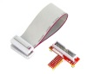 | Breakout Kit for Raspberry Pi to Breadboard | 800036001 | $5.50
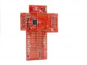 | M328W - wireless Internet of Things module | 317990029 | $18.50
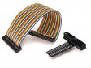 | Breakout Kit for Raspberry Pi Model B+ | 114990080 | $5.95
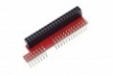 | Raspberry Pi B+ 40pin to 26pin GPIO Board | 114990109 | $6.95
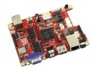 | Cubietruck Kit - Dual Core Single-board Computer | 800024001 | $94.90
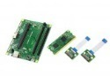 | Raspberry Pi Compute Dev Kit - BCM2835 32Bits ARM | 102110002 | $288.00
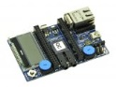 | mbed Application Board for LPC1768 | ARD00300P | $59.95
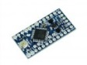 | Arduino Pro Mini 328 - 5V/16MHz | ARD05042M | $9.95
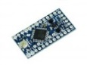 | Arduino Pro Mini 328 - 3.3V/8MHz | ARD05041M | $9.95
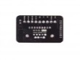 | GDA-HLB1 (Basic adapter for Gicren's Servo Controller) | 114990177 | $5.00
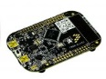 | Freescale FRDM-KL25Z | ARM04101B | $19.90
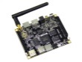 | Radxa Rock Pro | 102110004 | $97.75
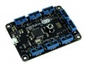 | Netduino Go | NET03112M | $49.95
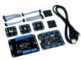 | Netduino Go Starter Kit | KIT03111M | $99.95
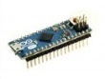 | Arduino Micro | ARD02021O | $24.90
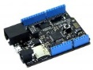 | Netduino Plus 2 | NET01082O | $59.95
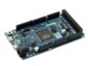 | Arduino Due | ARD12264M | $49.95
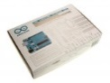 | Arduino Starter Kit | ACC12263M | $119.90
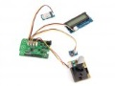 | UF0 - STM32F0 Cortex-M0, Arduino& Grove compatible Platform | 102990172 | $22.50
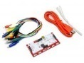 | Makey Makey | SEN12121O | $49.95
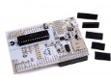 | Alamode - Arduino Compatible Raspberry Pi Plate | ARD10251P | $35.00
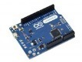 | Arduino Leonardo (+headers) | ARD07251M | $24.95
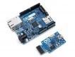 | Arduino Ethernet WITHOUT PoE + USB2SERIAL | ARD01161M | $63.20
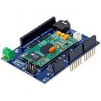 | EasyVR Shield for Arduino | SLD12652M | $46.50
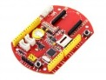 | Seeeduino Stalker v3 | 800162001 | $39.00
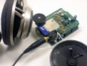 | Adafruit Wave Shield for Arduino Kit - v1.1 | SLD11412M | $21.50
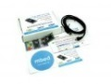 | mbed NXP LPC1768 Prototyping Board | ARM90153M | $59.50
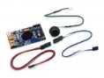 | EasyVR - multi-purpose speech recognition module | SEN81627M | $42.50
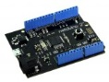 | Netduino 2 | NET71113M | $32.95
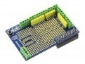 | Prototype Shield for Raspberry Pi | 820067001 | $8.70
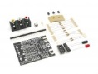 | Video Game Shield Kit | SLD51112M | $22.50
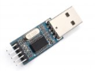 | PL2303 USB to Serial (TTL) Module/Adapter | 317990027 | $1.95
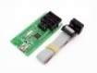 | AVR USB Programmer | TOL132C1B | $15.00
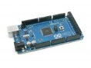 | Arduino Mega2560 Rev3 | ARD133C4M | $64.90
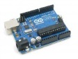 | Arduino Uno Rev3 | ARD132D2P | $29.90
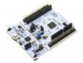 | NUCLEO L152RE - Development Board for STM32 | 820086001 | $11.50
 | NUCLEO F401RE - Development Board for STM32 | 820085001 | $11.50
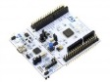 | NUCLEO F103RB - Development Board for STM32 | 820084001 | $11.50
 | NUCLEO F030R8 - Development Board for STM32 | 820083001 | $11.50
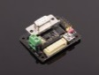 | GDA-HLU1 (USB adapter for Gicren's Servo Controller) | 114990178 | $13.00
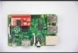 | Raspberry Pi B+ AD/DA Expansion Board | 103990060 | $10.95
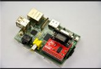 | Raspberry Pi GPIO to Serial port | 103990059 | $6.95
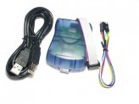 | Atmel AVRISP STK500 USB ISP Programmer | TOL102C3B | $29.50
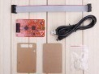 | Bus Blaster V3c for MIPS Kit | 110990445 | $43.95
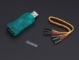 | ST-Link V2 for STM8 STM32 interface programmer | 114990173 | $9.50
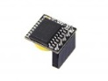 | Mini RTC Module | 800116001 | $5.49
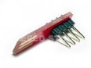 | Wiichuck- A Wii-Nunchuck break out board | INT105A4M | $4.00
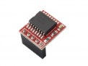 | RTC Module - Super Capacitor | 114990108 | $5.45
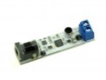 | The Whistled - A Sound Controlled Relay | ACT07111O | $25.00
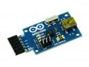 | USB 2 Serial Converter | TOL05232M | $14.90

Others | Name | SKU | Price
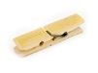 | Contemporary Minimalism DSO Nano Stand | TOL127B1B | $0.25
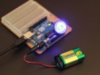 | Lens for SMD LED 14.6*23.6mm | 114990174 | $0.50
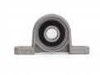 | Bearing Block KP08 | 323050020 | $2.85
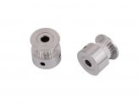 | S2M Synchronous Timing Belt Pulley | 114990160 | $3.75
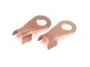 | Joint Buckle for Timing Belt | 114990159 | $0.99
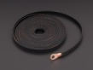 | Popbelt S2M-6mm toothed timing belt | 114990161 | $2.95
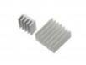 | Heat Sink Kit for Raspberry Pi B+ | 114990125 | $0.99
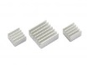 | Aluminum Heatsink Kit for Raspberry Pi | 800035001 | $2.90
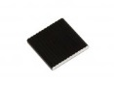 | Ultrathin Heat Sink for Cubieboard | 800019001 | $1.50
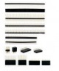 | Pin headers experimental pack | STR131B2P | $7.50
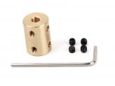 | Copper Shaft Coupler(5-8mm) | 323040015 | $3.50
 | Copper Shaft Coupler(6-8mm) | 323040016 | $3.50
 | Copper Shaft Coupler(6-10mm) | 323040017 | $1.90
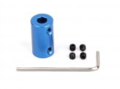 | Aluminum Shaft Coupler(6-6mm) | 323010070 | $1.90
 | Aluminum Shaft Coupler(5-6mm) | 323010071 | $1.90
 | Aluminum Shaft Coupler(5-5mm) | 323010072 | $1.90
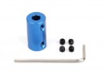 | Aluminum Shaft Coupler(4-6mm) | 323010073 | $1.90
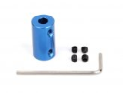 | Aluminum Shaft Coupler(4-5mm) | 323010074 | $1.90
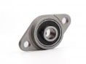 | Bearing Block KFL08 | 323050019 | $2.75
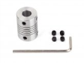 | Elastic Coupling(5-8mm) | 323050018 | $2.75
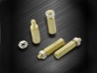 | Copper Cylinders for Raspberry Pi | 114990131 | $0.99
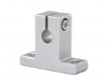 | Vertical axis bracket - Sk8 | 323030010 | $3.50
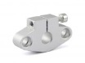 | Horizontal axis bracket - SHF8 | 323010036 | $3.99
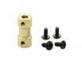 | Copper Coupling | 323040005 | $3.50
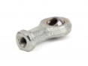 | Joint Bearing SI5T/K | 323030023 | $1.50
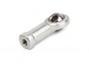 | Joint Bearing SI4T/K | 323030022 | $1.50
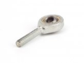 | Joint Bearing SA5T/K | 323030021 | $1.50
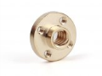 | Acme screw nut | 326030023 | $2.50
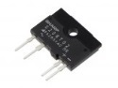 | Solid State Relay SHARP S208T02 | 231001001 | $4.90
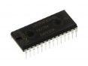 | LPC1114FN28 - ARM Cortex-M0 based 32-bit MCU (DIP) | 103041001 | $4.45
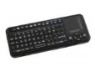 | Mini Wireless Keyboard and Touchpad Mouse - Rechargeable | 620045001 | $29.90
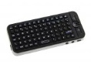 | Fly Air Mouse Mini Wireless Keyboard | 620046001 | $24.90
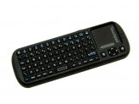 | Mini Wireless Keyboard and Touchpad Mouse | LED06071B | $29.90
 | Laser Keyboard Kit | 800028001 | $49.50
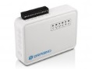 | Dragino V2 MS14-S with M32 IoT Module | 800114001 | $65.90
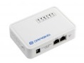 | Dragino V2 - IoT Sensor Node | 280009001 | $45.00
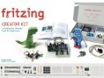 | Fritzing Creator Kit without Arduino UNO English Edition | 800054001 | $89.90
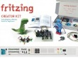 | Fritzing Creator Kit with Arduino UNO English Edition | 800050001 | $107.90
 | Insect bot | 110990448 | $35.00
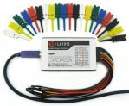 | LA1016 Logic Analyzer | 109990064 | $75.00
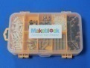 | Hardware Pack | 800107001 | $24.99
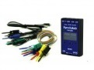 | Xprotolab Portable | TES00200M | $98.00
 | Peltier Plate - 30mm*30mm | TEM09241B | $3.90
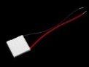 | Peltier Plate - 25mm*25mm | TEM08102B | $3.50
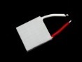 | Peltier Plate - 20mm*20mm | TEM08101B | $3.20
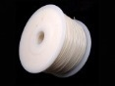 | 3D Printer ABS Filament - Original | ACC08221B | $15.00
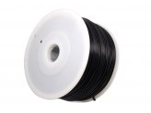 | 3D Printer ABS Filament - Black | ACC08222B | $15.00
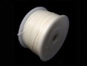 | 3D Printer PLA Filament - Original | ACC08227B | $23.90
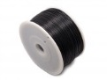 | 3D Printer PLA Filament - Black | ACC08228B | $23.90
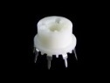 | Gas Sensor Socket | TEM11291B | $0.50
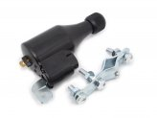 | Bicycle Dynamo With Bracket - 6V 3W | POW31944M | $6.90
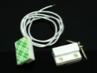 | Magnetic Door Switch | SEN114A2B | $2.00
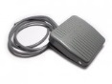 | Foot switch TFS201 | SWT129C6B | $5.50
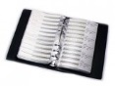 | 0805 SMT Capacitor sample book - 4416 pcs in 92 values(free shipping) | COM110B4O | $70.00
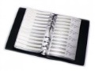 | 0805 SMT Resistor sample book - 8496 pcs in 177 values(free shipping) | COM109B4O | $60.00
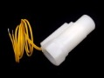 | Flow switch--MR-W1-P | SEN104A2B | $12.99
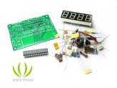 | Capacitance Meter Kit | TOL104C3M | $11.00
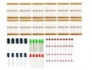 | 20 in 1!Basic components mixed pack | COM103B2P | $4.90
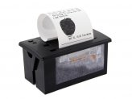 | Embedded Thermal Printer | 800023001 | $45.00
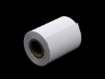 | Thermal Paper Roll - 57x50mm | 489001001 | $1.50
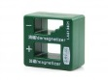 | Screwdriver Magnetizer/Demagnetizer | 114990066 | $5.90
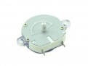 | Mechanical Timer | SEN00400P | $2.50
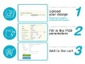 | Fusion PCBA | PCB06191P | $19.90
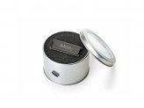 | iMetry | SEN04193M | $298.00
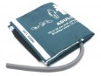 | C1711-Adult reusable NIBP cuff | MED61046M | $22.95
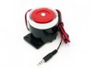 | scream out loud - 110dBA fixed tone Siren | COM101B8B | $9.50
Robot | Name | SKU | Price
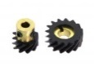 | Helical gear set (for 90 degrees transmission) | 114990061 | $4.50
 | Circumference 300m Wheel | 114990065 | $13.90
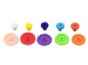 | High Speed Gear Kit - 18045 | 114990063 | $5.50
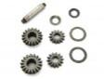 | Differential Gear Kit | 114990062 | $5.75
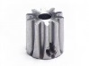 | General Shaft joint -p3 | MOT113A1B | $1.50
 | Mecanum Wheel Kit (2 Left, 2 Right) | 114990133 | $99.00
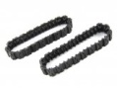 | Track With Track Axle(40-Pack) | 800109001 | $9.99
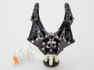 | Strong Robot Gripper | 800106001 | $29.99
 | Beam0808 Robot Pack - Blue | 800110001 | $24.99
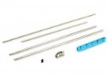 | Thread Drive Pack | 800105001 | $12.99
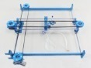 | XY-Plotter Robot Kit (No Electronics) | 800108001 | $189.99
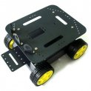 | 4WD Arduino compatible robot platform (global free shipping) | ROB103F3M | $51.00
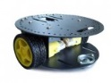 | 2WD Arduino compatible Mobile platform | ROB102F3M | $36.00
 | Multi Chassis Tank (Rescue Version) Robot Platform | 800015001 | $129.00
 | Multi Chassis-4WD Robot Kit (ATV version) | 800014001 | $45.00
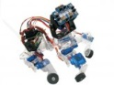 | Playful Puppy Quadruped Robot Kit | 800016001 | $119.00
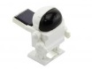 | Smart Solar Robot | 800017001 | $6.90

