HDMI 5 INCH TOUCH

User Manual

Description

5 inch Resistive Touch Screen LCD, HDMI interface, supports various systems

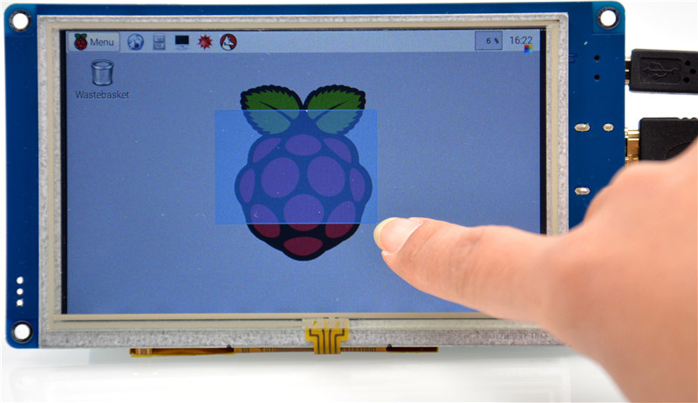

Features
- 800×480 high resolution, touch control
- Supports Raspberry Pi,BeagleBone with free-driver
- Supports Windows / Mac / Ubuntu PC
- Supports Lubuntu, Android Media Box / MiniPC
- HDMI interface for displaying, USB interface for touch control
- ULP Back light

1. | On-Board resource
Figure 1: Interfaces
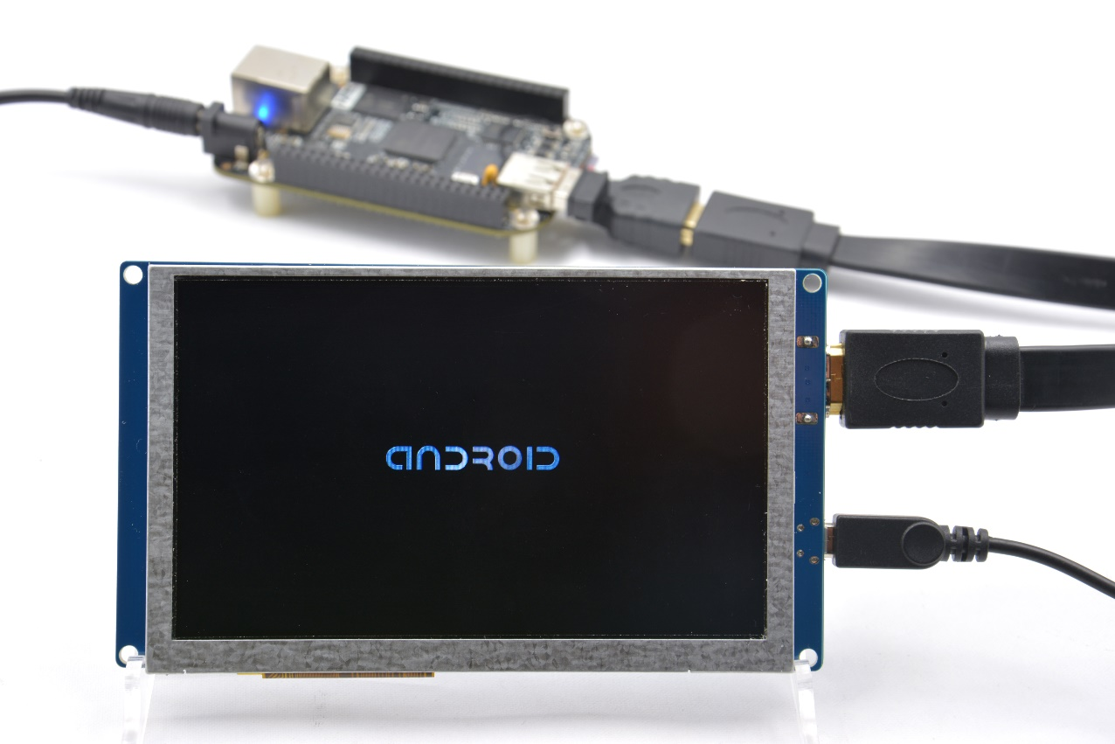
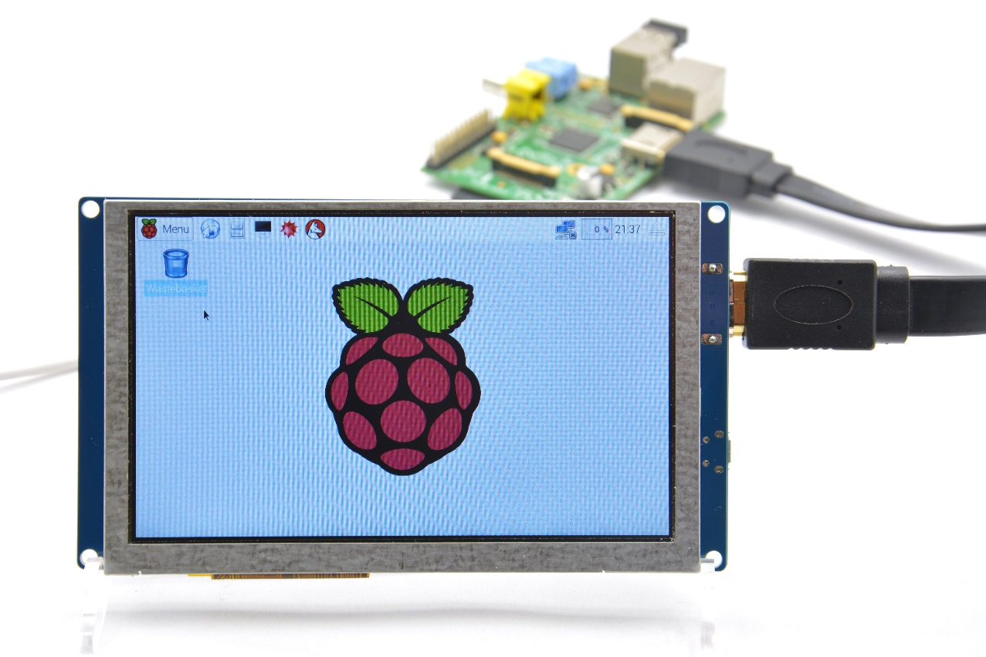
- HDMI: it is used for connecting the main board to the LCD screen.
- USB Touch Interface: USB touch/power interface.
2. | Working with Raspberry Pi
2.1. | Edit /boot/config.txt to change resolution
# uncomment if you get no picture on HDMI for a default "safe" mode
#hdmi_safe=1

# uncomment this if your display has a black border of unused pixels visible
# and your display can output without overscan
#disable_overscan=1

# uncomment the following to adjust overscan. Use positive numbers if console
# goes off screen, and negative if there is too much border
#overscan_left=16
#overscan_right=16
#overscan_top=16
#overscan_bottom=16

# uncomment to force a console size. By default it will be display's size minus
# overscan.
#framebuffer_width=1280
#framebuffer_height=720

# uncomment if hdmi display is not detected and composite is being output
hdmi_force_hotplug=1

# uncomment to force a specific HDMI mode (here we are forcing 800x480!)
hdmi_group=2
hdmi_mode=1
hdmi_mode=87
hdmi_cvt 800 480 60 6 0 0 0

# uncomment to force a HDMI mode rather than DVI. This can make audio work in
# DMT (computer monitor) modes
#hdmi_drive=2

# uncomment to increase signal to HDMI, if you have interference, blanking, or
# no display
#config_hdmi_boost=4

# uncomment for composite PAL
#sdtv_mode=2

#uncomment to overclock the arm. 700 MHz is the default.
#arm_freq=800

# for more options see http://elinux.org/RPi_config.txt
2.2. | Hardware connection
- Connect the LCD to the HDMI on the Raspberry Pi board with a HDMI cable;
- Connect the USB Touch interface on the LCD to the USB interface on the Raspberry Pi board with a USB type-A male to micro-B cable.
2.3. | Have fun.

3. | How to use with PC

3.1. | Plug & Play

